***Business Intelligence Life Cycle Process***

**Introduction -**

This report describing the process you will undergo during the contractual period. Using a graphical representation, provide a detailed discussion of the life cycle which includes defining the goal, collecting and managing data, building the model, evaluating and critique model, presenting results and documents and deploying a model.

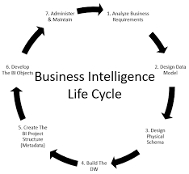

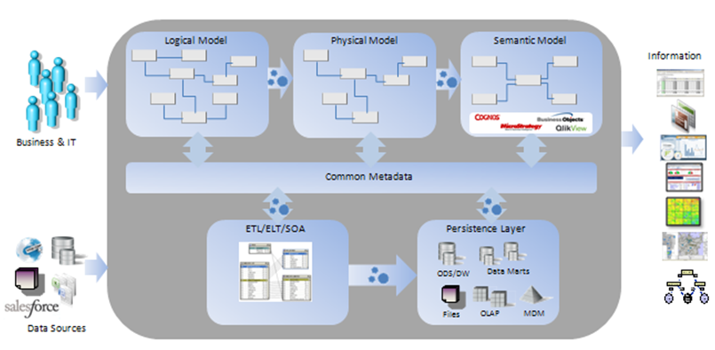

**What is B.I Life Cycle ?**

Business Intelligence (BI) initiatives are both time consuming and labour intensive, sometimes suffer from poor coordination between business and IT, and are usually unyielding to reform once implementation has started. This is attributed, in large part, to the process by which BI programmes have historically been applied.

It consists of steps that are required to move forward and for a successful business :

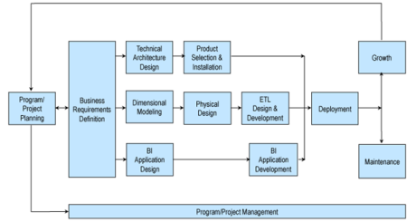

**Define the goal -**

Part of the planning process, the corporate priorities define what the company expects to do over a specified period of time. Businesses usually describe their goals and priorities in their business plans. The objectives may relate to the company as a whole, departments, employees, customers or any other area of business.

**Collect and manage data -**

Data is the bedrock of business information, expertise and, essentially, the insight to make the right decisions and behaviour. If these details are valid, full, reliable, useful and actionable, they should lead to the success of the enterprise. If not, it can prove to be worthless and even dangerous commodity for a growing company.

**Build the model -**

A new business in progress must have a business model, if only to attract investment, support to retain employees and inspire management and staff. Established businesses often need to review and revise their business plans, or they will continue to predict future trends and obstacles. Investors need to review and evaluate the business plans of companies that are of interest to them.

**Evaluate and critique model -**

"Business plans may be perfect for banks and analysts, but if businesses actually did follow them, you might never have heard of Compaq, Lotus, or Ben & Jerry's." This quotation is from "The Best-Laid Strategies," an essay in Inc. Paper, February 1987. The article examines some of America's best small businesses and examines their business plans and how useful they have been.

Many people say they haven't looked at the business plans for a long time, and that the plans didn't accurately forecast what really happened to the corporation! One can easily conclude that it's a waste of time to draw up a business strategy.

A thesis at the University of Texas. The study looked at organisations that had a formal business planning process, correlated actual performance with expected output, and also assessed whether or not they were working on a schedule basis. This study, like the Inc. article, found that companies that had formal organisational plans did not comply with those plans

**Present results and documents -**

A typical business plan for a food cooperative usually has:

* A description of the business, including its purpose and strategy
* An analysis of food industry trends
* An analysis of the market and the competition
* An analysis of other key internal and external factors affecting the business, including a historical financial analysis
* A description of how the cooperative will address the major strengths, weaknesses, threats, and opportunities outlined in the analysis
* A description of the market niche the cooperative is after and the products and services the co-op will offer to serve that niche
* A capital, cash, and operating budget, with assumptions

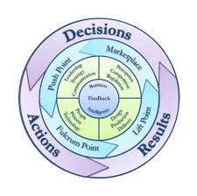

**Deploy model -**

The best implementation model for transformation depends on a number of different variables. When selecting a strategy, transition architects will think carefully about the intent of change, the nature of their organisation and the existing capacities of their staff, processes and management systems:

**Bottom up or top down:** where is the change needed in the organisation? Is the mechanism extremely manual, involving significant input from the frontline? Or is it more programmed, indicating the change has to come from the top?.

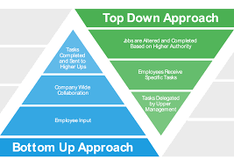

**Leadership engagement:** How are members supposed to be involved in transformation? Are there any big remote locations that could be converted independently?.

**Capability building:** What resources is the company going to need? Where are the current capacity holes, and how are they to be filled?

**Conclusion -**

In conclusion, this report describes the process you will undergo during the contractual period. Using a graphical representation, provide a detailed discussion of the life cycle which includes defining the goal, collecting and managing data, building the model, evaluating and critique model, presenting results and documents and deploying a model..

**References -**

RingLead. (2020). *The Importance of Data Management In Companies*. [online] Available at: https://www.ringlead.com/blog/the-importance-of-data-management-in-companies [Accessed 26 Jan. 2020].

Lifecycle, B. and Lifecycle, B. (2020). *Business Intelligence Lifecycle Management - Data Warehouse Tutorial*. [online] Intellipaat Blog. Available at: https://intellipaat.com/blog/tutorial/data-warehouse-tutorial/business-intelligence-lifecycle/ [Accessed 26 Jan. 2020].

Investopedia. (2020). *Understanding Business Models*. [online] Available at: https://www.investopedia.com/terms/b/businessmodel.asp [Accessed 26 Jan. 2020].

Grocer.coop. (2020). *How to Critique a Business Plan | Co-op Grocer Network*. [online] Available at: https://www.grocer.coop/articles/how-critique-business-plan [Accessed 26 Jan. 2020].

McKinsey & Company. (2020). *A better fit: Tailoring the deployment model to suit the organization*. [online] Available at: https://www.mckinsey.com/business-functions/operations/our-insights/a-better-fit-tailoring-the-deployment-model-to-suit-the-organization [Accessed 26 Jan. 2020].